**Step1**: Create 2 Linux ec2 instances with t2.medium

One as Central repository(Master) and 2(Slave machines) Hosts

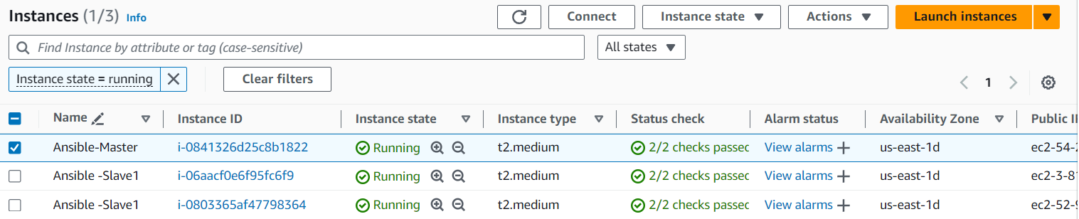

**Step2**: Login to each ec2 instance and follow the below steps

1. useradd ansible
2. passwd ansible
3. Add the below line in Vim /etc/sudoers

ansible ALL=(ALL) NOPASSWD: ALL

1. Add the below line in Vim /etc/ssh/sshd_config

passwordAuthentication yes

1. sudo service sshd restart

**Step3**: sudo su – ansible

**Step4**: Install the below steps in Master instance

1. sudo yum install python3 -y
2. python3 –version
3. sudo yum -y install python3-pip
4. pip3 install ansible –user
5. ansible –version

**step5**: sudo mkdir /etc/ansible

**step6**: Copy the data in the beow link and paste it in vim /etc/ansible/ansible.cfg

https://raw.githubusercontent.com/ansible/ansible/release1.8.4/examples/ansible.cfg

**step7**: Copy the data in the beow link and paste it in vim /etc/ansible/hosts and comment every line

<https://raw.githubusercontent.com/ansible/ansible/release1.8.4/examples/hosts>

**Step8**: Open vim /etc/ansible/hosts

add the private ips of both instance if they are in same Vpc else add public ip

copy the pem file from windows and create a file as paste it . ex:~/Devops.pem

provide the ips and username and pem file path as shown below

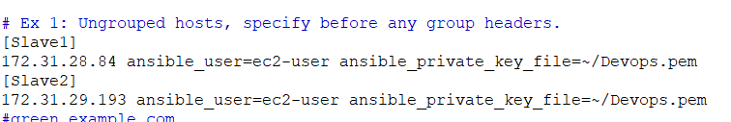

**Step9**: Open vim /etc/ansible/ansible.cfg

remove the comment for hostkey_checking=false

Note: this helps for not asking confirmation

**Step** **10:** chmod 400 ~/Devops.pem

**Step 11**: Perform the below command

ansible all -m ping

